

**21EC2016 INTERNET OF THINGS**

**QUALITY ASSESSMENT**

**REALTIME IoT SOFTWARE APP DEVELOPMENT**

**NIVEDHITHA G**

**URK21EC6040**

**Introduction**

A software application for game is developed with visual studio code software and python programming language.Python is a high level programming language and is simple to develop various websites and apps within short period of time.Python has the simplest syntax compared to other programming languages. Visual Studio Code is a free coding editor that helps you start coding quickly and also help us to develop software applications. Visual Studio Code has support for many languages, including Python, Java, C++, JavaScript, and more. Visual Studio Code highlights keywords in your code in different colours to help you easily identify coding patterns and learn faster. Visual Studio Code gives you suggestions to complete lines of code and quick fixes for common mistakes. You can also use the debugger in VS Code to step through each line of code and understand what is happening. When random colours on the screen are entered into the ‘input’ object and enter is pressed, the score is incremented if the prediction is correct. The game starts when enter is pressed.

**Program**

# import the modules

import tkinter

import random

# list of possible colour.

colours = ['Red','Blue','Green','Pink','Black',

           'Yellow','Orange','White','Purple','Brown']

score = 0

# the game time left, initially 30 seconds.

timeleft = 30

# function that will start the game.

def startGame(event):

    if timeleft == 30:

        # start the countdown timer.

        countdown()

    # run the function to

    # choose the next colour.

    nextColour()

# Function to choose and

# display the next colour.

def nextColour():

    # use the globally declared 'score'

    # and 'play' variables above.

    global score

    global timeleft

    # if a game is currently in play

    if timeleft > 0:

        # make the text entry box active.

        e.focus_set()

        # if the colour typed is equal

        # to the colour of the text

        if e.get().lower() == colours[1].lower():

            score += 1

        # clear the text entry box.

        e.delete(0, tkinter.END)

        random.shuffle(colours)

        # change the colour to type, by changing the

        # text _and_ the colour to a random colour value

        label.config(fg = str(colours[1]), text = str(colours[0]))

        # update the score.

        scoreLabel.config(text = "Score: " + str(score))

# Countdown timer function

def countdown():

    global timeleft

    # if a game is in play

    if timeleft > 0:

        # decrement the timer.

        timeleft -= 1

        # update the time left label

        timeLabel.config(text = "Time left: "

                               + str(timeleft))

        # run the function again after 1 second.

        timeLabel.after(1000, countdown)

# Driver Code

# create a GUI window

root = tkinter.Tk()

# set the title

root.title("COLORGAME")

# set the size

root.geometry("375x200")

# add an instructions label

instructions = tkinter.Label(root, text = "Type in the colour"

                        "of the words, and not the word text!",

                                      font = ('Helvetica', 12))

instructions.pack()

# add a score label

scoreLabel = tkinter.Label(root, text = "Press enter to start",

                                      font = ('Helvetica', 12))

scoreLabel.pack()

# add a time left label

timeLabel = tkinter.Label(root, text = "Time left: " +

              str(timeleft), font = ('Helvetica', 12))

timeLabel.pack()

# add a label for displaying the colours

label = tkinter.Label(root, font = ('Helvetica', 60))

label.pack()

# add a text entry box for

# typing in colours

e = tkinter.Entry(root)

# run the 'startGame' function

# when the enter key is pressed

root.bind('<Return>', startGame)

e.pack()

# set focus on the entry box

e.focus_set()

# start the GUI

root.mainloop()

**Output**

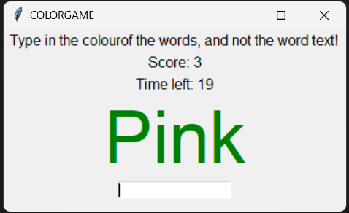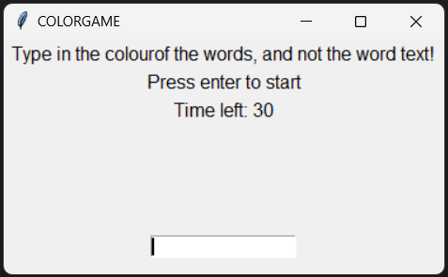

**Reference:**

https://youtu.be/ODgJg5TTGKA?si=72zbgdjZ5XtiVT3P